**CLOUD APPLICATION DEVELOPMENT LAB**

NAME- Shubhi Dixit

SAP ID- 500094571

BATCH- 05

**Aim- Develop a prototype application using Cloud Platform API with AWS Cloud.**

**Step-1:** Go to AWS console and search for IAM. Go to roles and click on “Create role”.

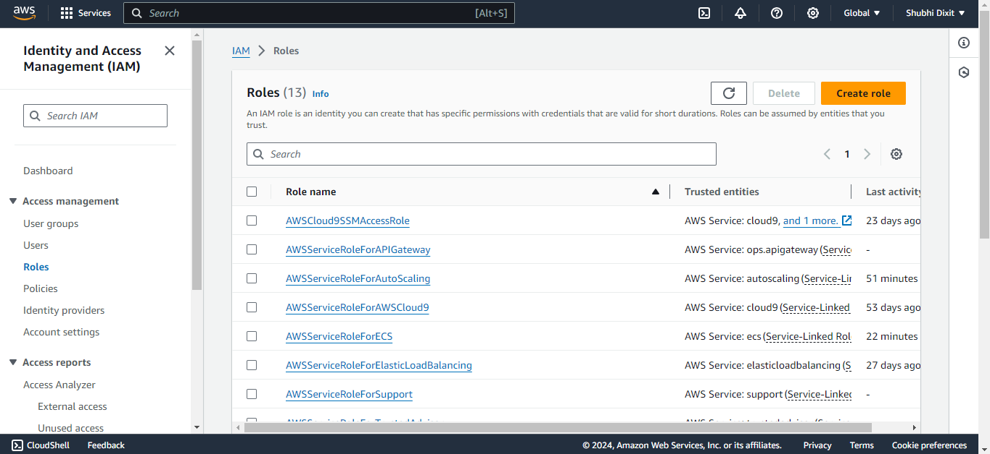

**Step-2:** Select the “AWS service” option and select “Lambda”

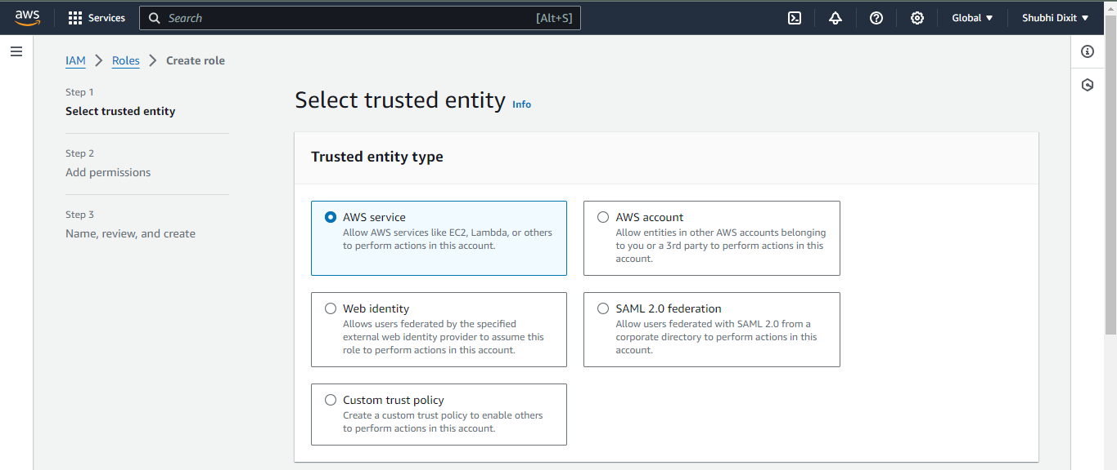

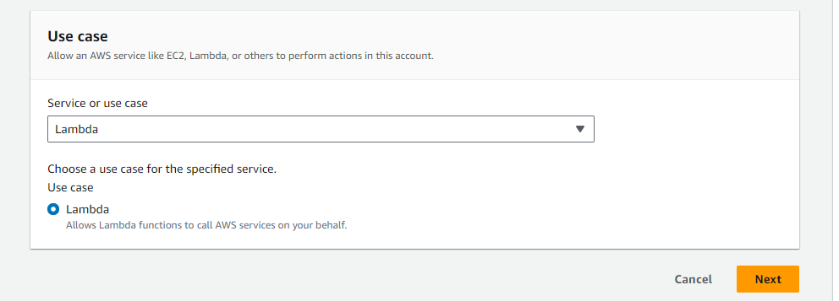

**Step-3**: Attach the following permissions to the role: “AWSLambda_FullAccess”

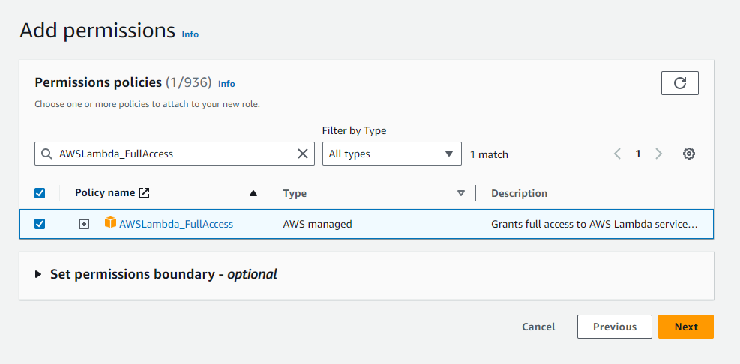

**Step-4:** Give a name to your role

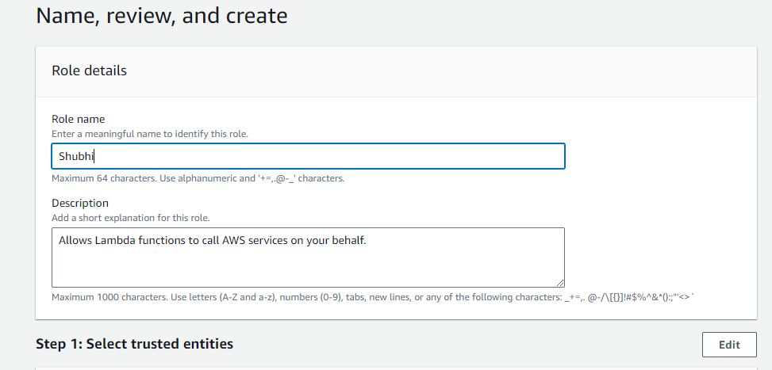

**Step-5:** Go to Lambda and click on “Create function”

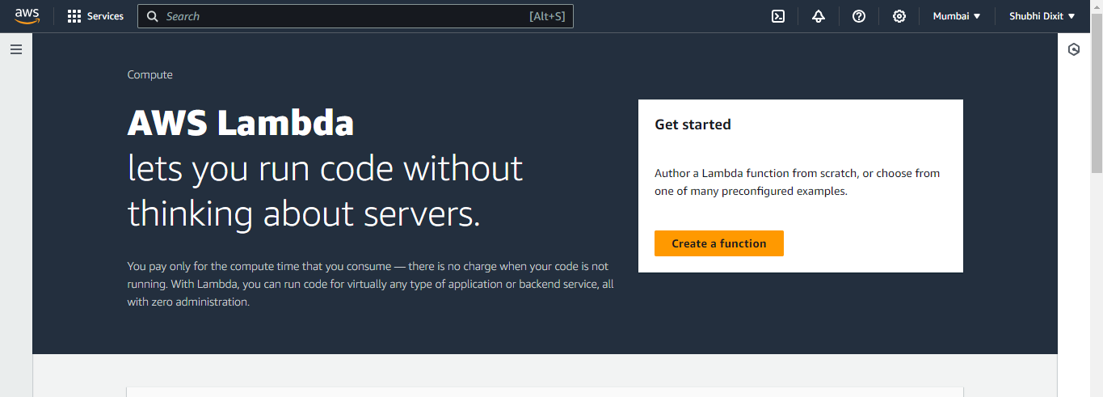

**Step-6:** Give the function name, language as nodejs and attach the IAM role that you just created.

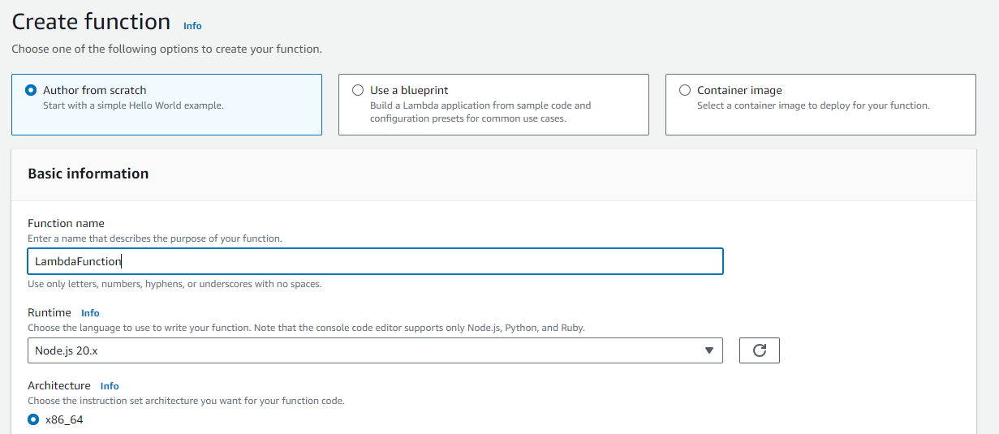

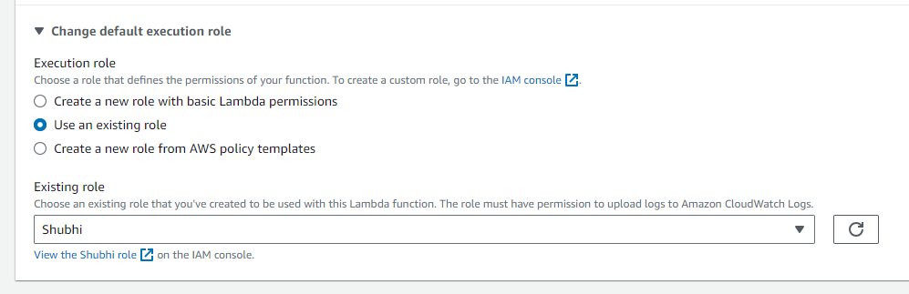

**Step-7:** Click on create function

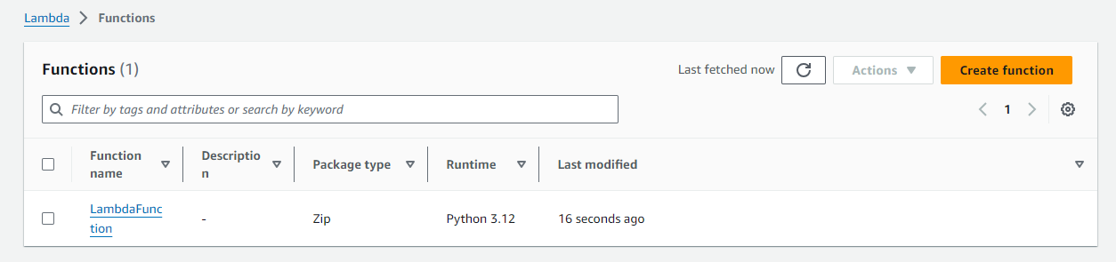

**Step-8:** Now copy the below code in the code editor in lambda function. Deploy the code and save it.

export const handler = async (event) => {

const response = {

statusCode: 200,

body: JSON.stringify('Hello from Lambda!'),

};

return response;

};

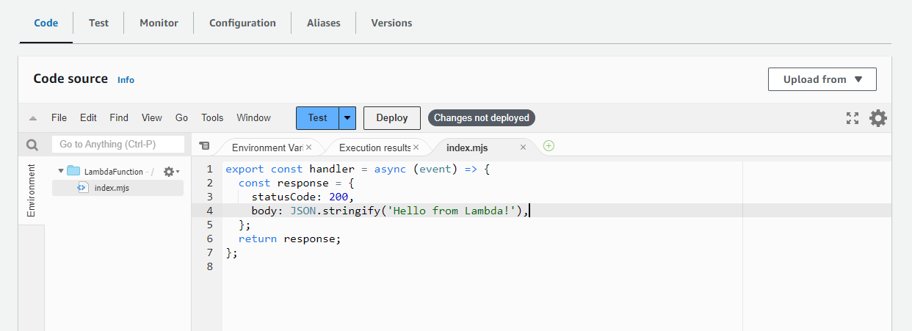

**Step-9:** Now test the function. Create a sample event and save it, then run the test.

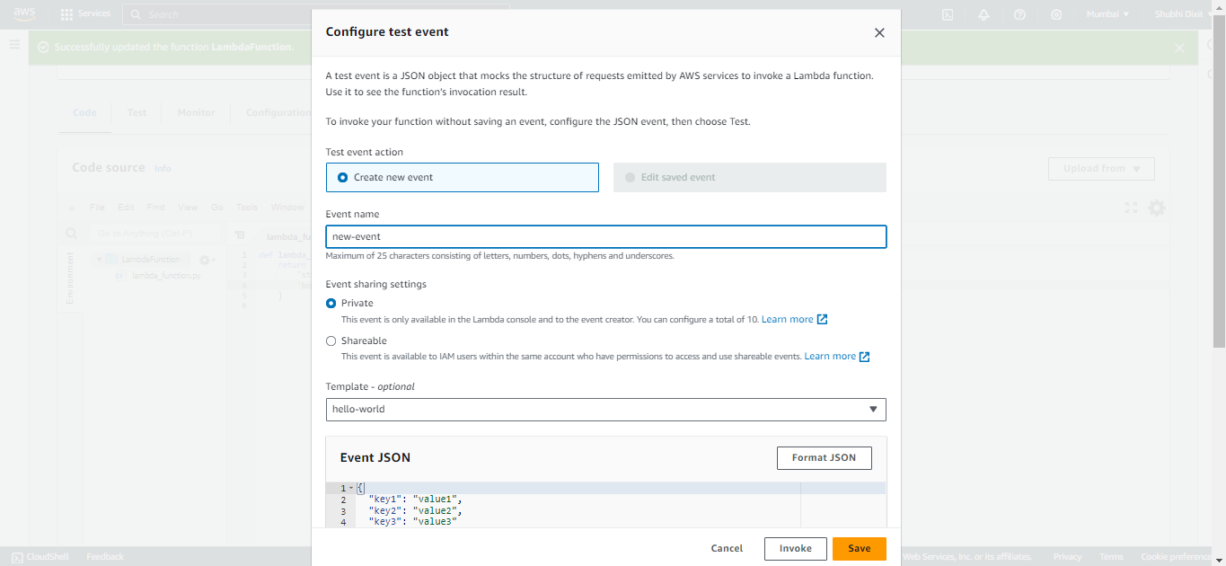

**Step-10:** Now you can see that the execution results show positive response i.e. our lambda function is successfully executing.

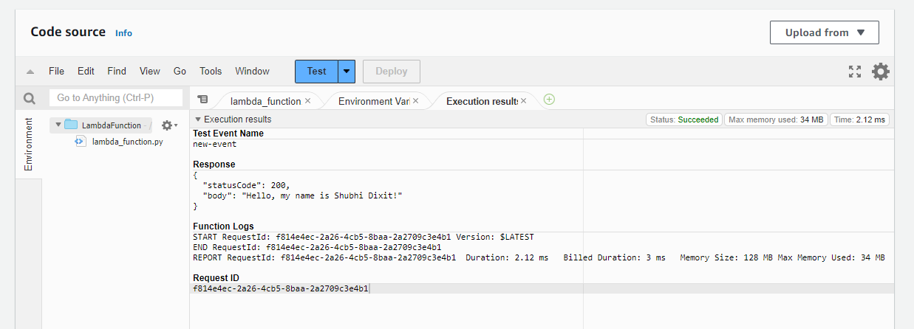

**Step-11:** Go to Amazon API Gateway and chose “Build” option from HTTP API.

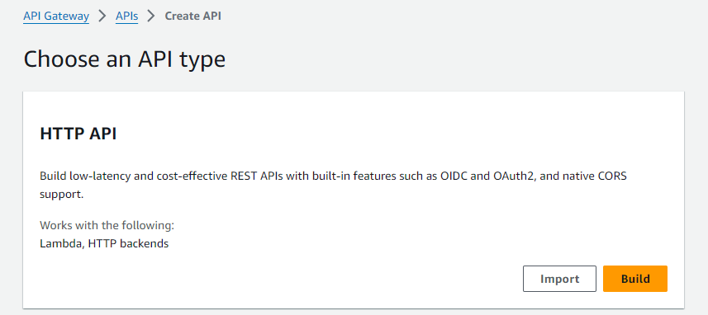

**Step-12:** Click on “Create API” and name it.

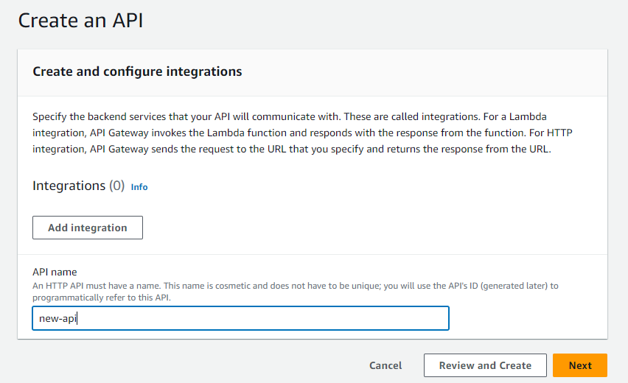

**Step-12:** In the attach integration option, select "Lambda function" as the integration type and pick the Lambda function you created earlier.

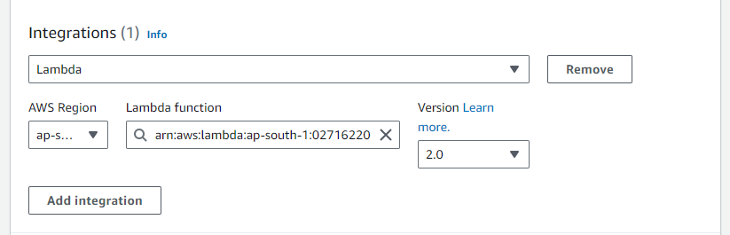

**Step-12:** Click on "Configure routes" and set up the initial route:

* Enter the route path (e.g., /myresource).
* Select the HTTP method (e.g., GET).

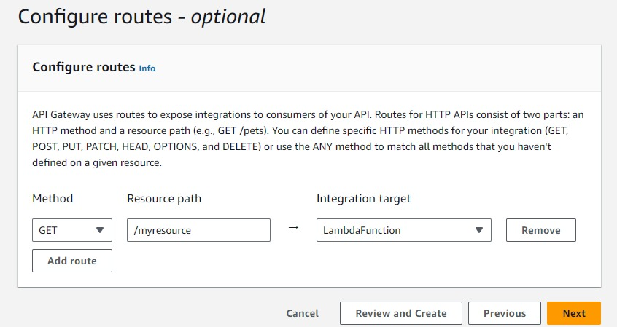

**Step-13:** Skip "Configure stages" step since you are using the $default stage. In this, AWS will automatically utilize the $default stage for the deployment.

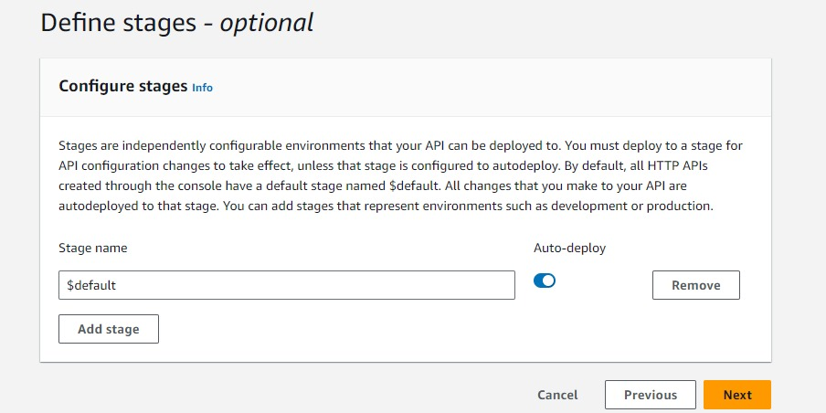

**Step-14:** Select the Stages option on the left-hand menu. You should see the $default stage listed there. Click on the $default stage.

On the stage details page, you will find the Invoke URL.

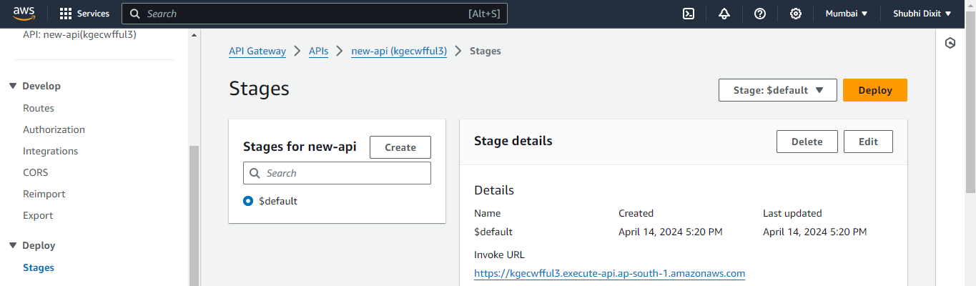

**Step-15:** Use this URL to make requests to your deployed API.

“<https://kgecwfful3.execute-api.ap-south-1.amazonaws.com/myresource>”

**Note- For the $default stage, you don't need to append the stage name to the URL; you directly append the resource path to the invoke URL to form the complete endpoint you can call.**

**For example, if your resource path is /myresource, the complete URL would be “https://<api-id>.execute-api.<region>.amazonaws.com/myresource.”**

